Genetics Practice Exam
1. Gregor Mendel’s work explained many of the patterns of inheritance commonly found in nature, but Mendel was unable to explain the physical mechanisms of genetics, which would be worked out over a hundred years later. Mendel realized that there must be a molecule that was passed between parents and offspring that accounted for physical appearances and called that unknown molecule the “heritable factor”. Which of the following best explains why biologists today consider DNA that mysterious “heritable factor”?
A. DNA molecules are split into chromosomes and every species has a different number of chromosomes, accounting for the differences between species
B. DNA is found in the nucleus of all cells, which is where transcription and translation are known to occur and thus is the most likely candidate for the heritable factor
C. DNA is found in all living organisms while proteins are only found in certain taxonomic groups- suggesting that only DNA can be the heritable factor
D. DNA contains four different bases, the order of which can serve as a genetic code for the assembly of different proteins that manifest into physical traits, and is double stranded so that each strand may serve as a template for making new DNA molecules that can be passed on to offspring
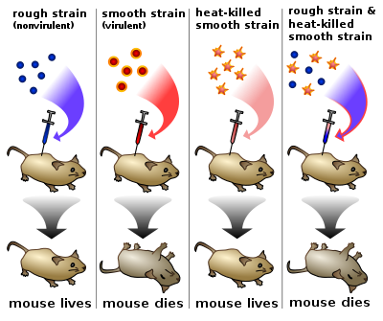
2 The Avery, Macleod and McCarty experiment sought to explain the findings of Frederick Griffith, who in 1928 examined the process of transformation in bacteria. One population of the bacteria, known as the virulent strain, was lethal to mice. The other population, or nonvirulent strain, did not harm the mouse. However, Griffith showed that when heat-killed virulent bacteria were mixed with live non-virulent bacteria the non-virulent strains were “transformed” into virulent bacteria and were capable of killing a mouse, as shown below.
Avery, Macleod and McCarty repeated the process but experimented with different digestive enzymes which broke apart different extra-cellular molecules that could be passing between bacteria. The results of injecting a mouse with a mixture of heat-killed virulent bacteria, live non-virulent bacteria and different enzymes are shown in the table below:
Enzyme | Enzyme Target | Mouse
Trypsin | Proteins | Dead
Ribonuclease | RNA | Dead
DNAdepolymerase | DNA | Alive
Trypsin + Ribonuclease | Proteins and RNA | Alive
Trypsin and DNAdepolymerase | Proteins and DNA | Dead
Ribonuclease and DNAdepolymerase | DNA and RNA | Dead
Which of the following best explains the results of this experiment?
A. The fact that the mouse dies when the injection contained trypsin and ribonucleases show that proteins and RNA are essential to the proper functioning of a mouse
B. The fact that the mouse dies when both DNA and RNA were digested suggests that DNA codes for RNA
C. The fact that the mouse lives when DNA is digested suggests that DNA is the transforming agent causing the non-virulent strain to become virulent and is likely a source of heritable information
D. The fact that the mouse lives when trypsin and DNAdepolymerase are added suggests that DNA codes for proteins

3. When DNA replicates, each strand of the original DNA molecule is used as a template for the synthesis of a second, complementary strand. Which of the following figures most accurately illustrates enzyme-mediated synthesis of new DNA at a replication fork?
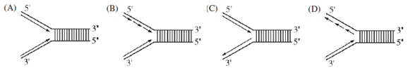
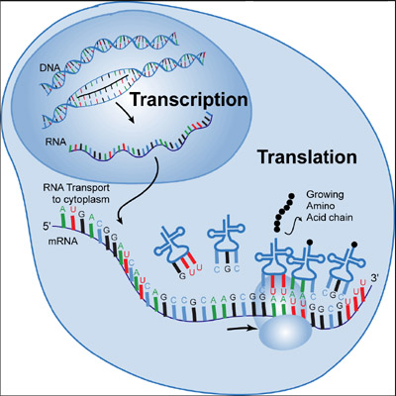
4. Which of the following best explains how the DNA code is eventually translated into a functional polypeptide, as shown in the diagram to the right?
A. The DNA is deoxygenated to become mRNA which eventually is translated into tRNA which assembles amino acids together
B. The DNA sequence codes for unique tRNAs for every protein. The tRNAs that are made determine the sequence of amino acids in the polypeptide
C. The DNA sequence is transcribed into an identical mRNA sequence which is then taken to the cytoplasm. The tRNA carrying an anticodon identical to the codon brings the appropriate amino acid in order
D. An mRNA sequence complementary to the DNA sequence is synthesized in transcription. In translation complementary tRNA molecules bring specific amino acids in order to the polypeptide chain based on the mRNA sequence
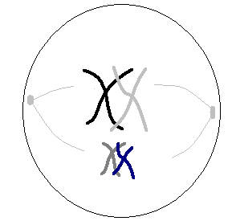
5. Predict what the end result will be for this cell currently going through the cell cycle
A. Two identical daughter cells will be formed that contain 4 chromosomes
B. Two identical daughter cells will be formed that contain 2 chromosomes
C. Four non-identical daughter cells will be formed, each containing a unique combination of 2 chromosomes
D. Four identical daughter cells will be formed that contain 2 chromosomes

6. Normal translation of a particular gene into a polypeptide is shown below.
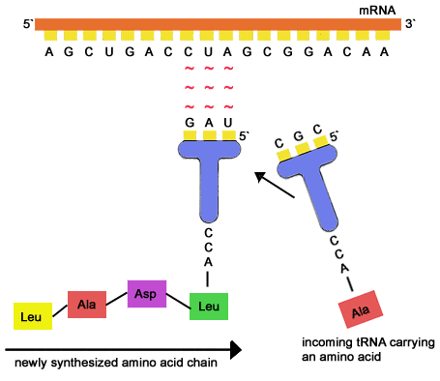
Sketch how a point mutation in the DNA would lead to an altered protein product (you may use a codon table)

7. The protein would be most affected if the point mutation
A. switched a large amino acid in for a smaller amino acid, which would drastically change the size of the protein
B. caused a substitution in an amino acid that formed a bond producing the protein’s functional shape
C. affected a nucleotide that was present in the intron region of the DNA
D. changed the third nucleotide in a codon as opposed to the first two
8. Using #6 as an example, and a codon table, sketch out the effects of a deletion mutation

9. Which of the following best exemplifies the evolutionary benefits of meiosis in sexual reproduction?
A. Meiosis requires less energy than mitosis and provides an advantageous cell division
B. Meiosis occurs more rapidly than mitosis, providing an advantage in reproduction for individual organisms
C. Meiosis produces more cells than mitosis, increasing the odds of fertilization
D. Meiosis produces new combinations of genetic traits, which increases the likelihood of individuals capable of surviving different environmental challenges
10. Which of the following best shows why linked genes, in this case (two dominant alleles for genes A and B) from a father tend to get passes together to his offspring?
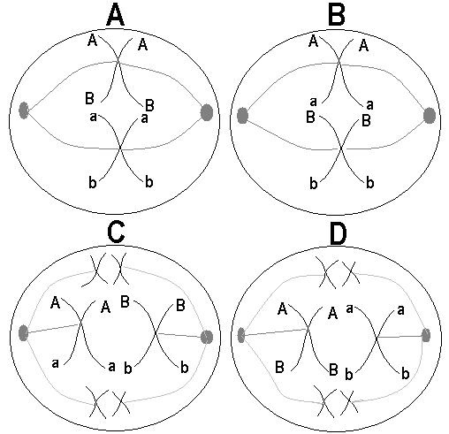
11. When Mendel crossed two individuals who were heterozygous in both traits he usually observed a 9:3:3:1 pattern where 9/16ths of the offspring showed the dominant phenotype in both characters, 3/16ths showed the dominant phenotype in the first character but not the second, 3/16ths showed the dominant phenotype in the second character but not the first and only 1 out of every 16 showed the recessive phenotype in both characters. However many times when crossing two individuals heterozygous in two genes, different percentages for each phenotype are shown or entirely new phenotypes appear. Which of the following is LEAST likely to explain a deviation from the 9:3:3:1 pattern?
A. If the genes are located close together on the same chromosome then certain alleles are more likely to be inherited together
B. if one or both of the genes are located on the X chromosome then the occurrence of each phenotype might differ for males and females
C. there could be another gene which also affects one or both of the observed phenotypes and disrupts the 9:3:3:1 pattern
D. if the genes are located on different chromosomes then we would expect them to independently assort and we would expect equal numbers of each of the four possible phenotype combinations
12. Both humans and fish contain the genes necessary for producing tails, gills and other structures which are only seen in fish. Which of the following best explains why these traits appear in fish but not in humans despite our containing the genes for them?
A. The traits are dominant in fish but are recessive in humans and so they are not expressed because most humans contain a dominant allele
B. The genes for producing these traits in humans are most likely inactivated in human cells
C. Humans do not contain the proper tRNAs or amino acids to correctly and properly produce the polypeptides needed to express these traits
D. These traits are probably deleted from the DNA code early on in human development when we are still an embryo
13. Many genes are turned on by the presence of nearby cells, allowing cells to work together and form a functional tissue. However, many times cells in a tissue require further specialization and must prevent production of certain proteins, even when the gene is “activated”. Which of the following best exemplifies how this occurs?
A. The production of extra transcription factors
B. Acetylation of the histone proteins to induce loosening of the DNA
C. Production of microRNAs which bind to the messenger RNA
D. Lysosomal destruction of ribosomes to prevent translation
(L.O. 3.18)
14. DNA to be inserted into bacterial vectors must first be altered. Which of the following best explains why?
A. The DNA of bacteria contains introns while eukaryotic DNA does not
B. Bacteria utilize different amino acids than eukaryotes and thus transcription occurs differently
C. The ribosomes of bacteria recognize a different sequence of codons than the ones present on eukaryotic mRNA
D. The DNA of eukaryotes contains introns while bacteria do not contain spliceosomes for removing them
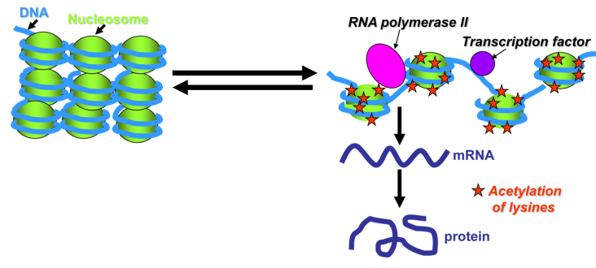
15. The diagram to the left exemplifies how
A. genes can be permanently modified by prokaryotic gene expression mechanisms
B. introns are spliced from the primary transcript during eukaryotic transcription
C. gene expression can be altered by different mechanisms in eukaryotes
D. DNA mutations can permanently alter the structure and function of a eukaryotic chromosome
16. As shown in the diagram on the previous page, histone acetylation increases the likelihood of
A. transcription occurring which will in turn increase the occurrence of translation into a functional polypeptide product
B. translation occurring which will in turn increase the occurrence of transcription of the DNA into a functional messenger RNA molecule or transfer RNA molecule
C. DNA replication occurring which will allow the cell to divide by either mitosis or meiosis
D. the gene being silenced as it is not necessary for the proper functioning of this particular cell though it may be important in others
17. Which of the following best describes the difference between DNA polymerase and RNA polymerase?
A. DNA polymerase functions mostly in eukaryotes while RNA polymerase functions mostly in bacteria and viruses
B. DNA polymerase functions mostly in DNA replication while RNA polymerase functions mostly in transcription
C. DNA polymerase functions mostly in transcription while RNA polymerase functions mostly in translation
D. DNA polymerase digests DNA molecules while RNA polymerase digests RNA molecules
18. An individual is attempting to make many copies of a small segment of DNA. They place the DNA sample, primers, Taq DNA polymerase and a large supply of DNA nucleotides into a chamber. After they heat the chamber for 45 minutes they turn off the heat and discover that the DNA has only been copied once. Which of the following best explains their results?
A. The heat denatured the Taq polymerase after the first replication
B. The primers were destroyed during the first replication and could not be used for further replications
C. The DNA strands were only separated once, so they could only be copied once
D. They forgot to add a supply of Taq polymerase after each replication
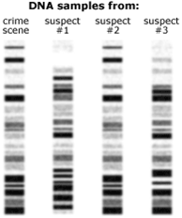
19. Gel electrophoresis can be used to match DNA samples, for example matching suspects to DNA found at a crime scene, as shown below. We can distinguish that suspects 1 and 3 have DNA that does not match the crime scene. Their DNA must be
A. differ in the epigenetic markers found throughout the genome
B. differ at several sequences where restriction enzymes cut the DNA
C. differ in how tightly wrapped certain genes are around histone proteins
D. contain shorter sequences than suspect #2’s DNA

20. If we first ran a gel electrophoresis on the crime scene and our results did not show any clear differences between two suspects, the best course of action would be to
A. run the gel electrophoresis again with a stronger voltage
B. use an additional restriction enzyme in digesting the DNA
C. use PCR to get more copies of the DNA prior to electrophoresis
D. arrest them both and charge them both with the crime
21. In DNA sequencing, fluorescently labeled di-deoxynucleotides are mixed with regular nucleotides during the synthesis of a sequence of DNA. The next step of the process is to
A. digest the fragments with restriction enzymes
B. insert the fragments into plasmids
C. separate the fragments by size
D. replicate the fragments via PCR
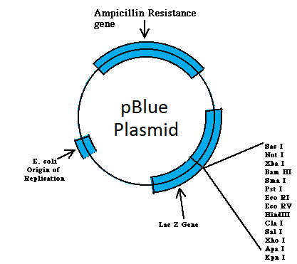
22-23 The diagram to the left represents a plasmid commonly used to transform bacteria. The plasmid contains and ampicillin gene and a lac Z gene. The lac Z gene codes for an enzyme, beta galactosidase, which breaks down lactose. However, it also breaks down X-gal into a blue chemical. The lacZ gene has several restriction sites in it, while the ampicillin gene does not.
22. The purpose of the restriction sites is to
A. ensure that genes on the plasmid will get expressed in the bacteria
B. allow the plasmid to be inserted into the bacterial chromosome
C. allow the bacteria that are transformed with plasmids to be visually separated from those that are not
D. allow DNA to be inserted into the plasmid
23. Bacteria that are transformed with the gene of interest can be identified. They will be
A. the white bacteria growing in ampicillin and X-gal B. the blue bacteria growing in ampicillin and X-gal
C. the blue bacteria growing in just ampicillin D. the white bacteria growing in just X-gal
24. The gene inserted into the bacterium is usually not expressed. However, the bacteria can be induced to produce the protein in the presence of lactose. You can therefore infer that lactose
A. is a repressor molecule that binds to the operator
B. lactose binds to a repressor molecule and alters its functional shape
C. lactose binds to an inactive repressor molecule and changes its shape to match the operator
D. lactose binds to the histone proteins and loosens their hold on the DNA
25. An mouse has a strange mutation that causes whiskers to start growing where a leg should. The mutation most likely occurred in
A. either the whisker gene or the leg gene B. in genes that control apoptosis of cells
C. genes that code for microRNAs D. a homeotic gene
26. The Spemann-Mangold experiment involved transplanting a small tissue from one frog embryo into another, as shown below:
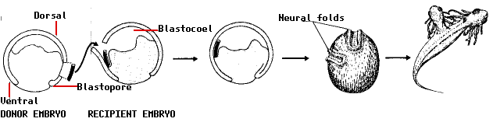
Spemann showed that no matter where he implanted the tissue from the donor embryo, a neural fold would grow in the host. This best demonstrates the principle that
A. cells are predetermined to grow into a certain type of cell depending on gene expression
B. the genetic instructions present in one embryo are essentially the same as genetic instructions in other embryos
C. one cell can induce the cells around it to develop in a certain pattern by altering their gene expression
D. the hox genes in each cell are the sole determinant of what type of tissue that cell develops into

