Experiment #1 Patty Power:
Mr. Krabbs wants to make Bikini Bottoms a nicer place to live. He has created a new sauce that he thinks will reduce the production of body gas associated with eating crabby patties from the Krusty Krab. He recruits 100 customers with a history of gas problems. He has 50 of them (Group A) eat crabby patties with the new sauce. The other 50 (Group B) eat crabby patties with sauce that looks just like new sauce but is really just mixture of mayonnaise and food coloring. Both groups were told that they were getting the sauce that would reduce gas production. Two hours after eating the crabby patties, 30 customers in group A reported having fewer gas problems and 8 customers in group B reported having fewer gas problems.

Experiment #2 Delicious Dish:
Jennifer wants to test the effectiveness of a new type of dishwashing detergent. She takes three groups of the exact same dishes and washes all three in the same dishwasher. With the first group, she uses the new detergent, the second group gets her old detergent, and the third group gets washed in plain water. She records the cleanliness of the dishes as data.

Experiment #3 Fuzzy Teeth:
A dentist wants to test different toothpaste brands to see which one works best to recommend to his patients. He takes 4 groups of 25 people and gives group #1 brand A, group #2 brand B, group #3 brand C and group#4 brushes with water only. Each person brushes with the same toothbrush and water. After 3 days, the dentist records the levels of tarter build-up in each person’s mouth.

Experiment #4 Microwave Miracle:
Patrick believes that fish that eat food exposed to microwaves will become smarter and would be able to swim through a maze faster. He decides to perform an experiment by placing fish food in a microwave for 20 seconds. He has the fish swim through a maze and records the time it takes for each one to make it to the end. He feeds the special food to 10 fish and gives regular food to 10 others. He uses the same type of fish for each group, and the same maze. After 1 week, he has the fish swim through the maze again and records the times for each.
Experiment #5 Mold Madness:
A class is learning about mold, and wants to know if temperature influences mold growth. They take three batches of the same type of bread and size of slices and places the three batches in different temperatures. Batch A is held at 35 degrees Celsius, group B at room temperature and group C at 10 degrees Celsius. The results are shown.

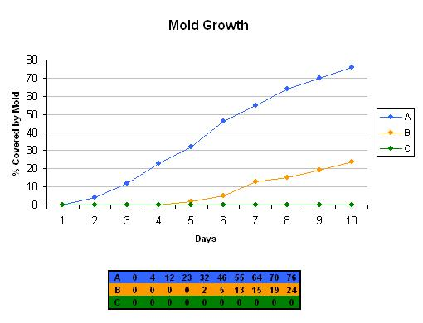

Experiment #6 Milk Mustache:
Some species of bacteria are harmful. Antibiotics are chemicals that kill bacteria. Some bacteria are resistant to antibiotics and are not killed by these chemicals. Over time, the resistant bacteria can reproduce and create populations that are not affected by antibiotics.
The graphs below show the results of a controlled experiment that measured the population of one species of bacteria that had been grown in four containers under identical conditions (same light, temperature, and type of container). Different antibiotics were added to three of the four containers.

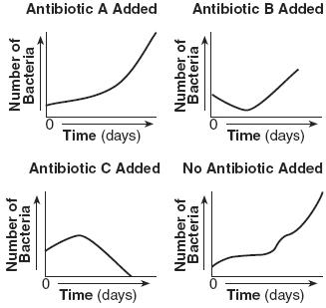

Experiment #7 Clean the Kitchen:
Andrew wants to test a new kitchen counter cleaner. He splits his counter into two parts using tape. The first section he cleans with water only and the second section he cleans using the new cleaner. The two sections are the same type of counter and in the same area of the kitchen. He records the number of bacteria after one week of cleanings.

Experiment #8 Student Study:
A teacher wants to study the affect of number of hours of studying on test results. She has five classes. The first class she has study zero hours, the second studies one hour, the third studies two hours, the fourth studies three hours, the fifth studies four hours. She records the average test score for each class. The students are given the same study materials, amount of sleep, and the same amount type of food and water.

Experiment #9 Slimotosis:
Sponge Bob notices that his pal Gary is suffering from slimotosis, which occurs when the shell develops a nasty slime and gives off a horrible odor. His friend Patrick tells him that rubbing seaweed on the shell is the perfect cure, while Sandy says that drinking Dr. Kelp will be a better cure. Sponge Bob decides to test this cure by rubbing Gary with seaweed for 1 week and having him drink Dr. Kelp the second week. After a week of treatment, the slime is gone and Gary’s shell smells better.

Experiment #10 Marshmallow Muscles:
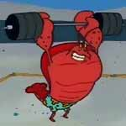Larry was told that a certain muscle cream was the newest best thing on the market and claims to double a person’s muscle power when used as part of a muscle-building workout. Interested in this product, he buys the special muscle cream and recruits Patrick and Sponge Bob to help him with an experiment. Larry develops a special marshmallow weight-lifting program for Patrick and Sponge Bob. He meets with them once every day for a period of 2 weeks and keeps track of their results. Before each session, Patrick’s arms and back are lathered in the muscle cream, while Sponge Bob’s arms and back are lathered with the regular lotion.

Experiment #11 Understanding Impact:
Scientists want to test the affect of speed on the impact of automobiles. The scientists use same type of automobile and impact site. The results of the experiment are shown below.
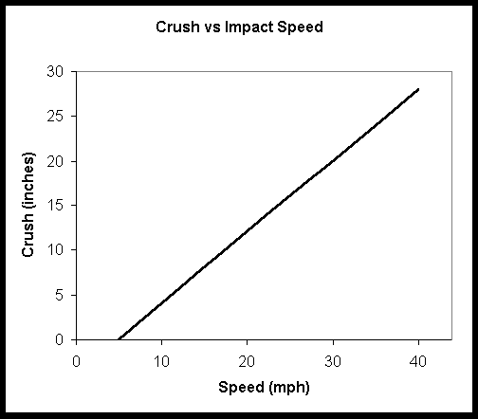

Experiment #12 Sleep Importance:
A researcher wanted to study the effects of sleep deprivation on physical coordination. The researcher selected 25 year-old male college students and deprived some of the subjects to either 24, 36, or 45 hours of sleep. He tested their physical coordination by recording how well they perform with the same physical coordination test.

Experiment #13 Rat Race:
Dr. Imanut wants to examine whether a new drug increases the maze running performance of older rats. Dr. Imanut teaches two groups of older rats to find a piece of tasty rat chow in the maze. One group of rats is given the new drug while they are learning the maze. The second group is not given the drug. One week after having learned the maze he retests the rats and records how long it takes them to find the rat chow.

Experiment #14
A consumer advocate group wants to test whether a fertilizer company’s claim that plants grow taller with their fertilizer is accurate. They perform the following experiment: Forty coleus plants are grown from clippings of a single plant. All of the plants are approximately the same height at the start of the experiment. Twenty of the plants receive the recommended amount of fertilizer with each watering. The remaining twenty plants receive the same amount of water with no fertilizer. All forty plants are grown at 25 ˚C with 10 hours of light daily. The height of each plant is recorded every 5 days for 2 months.

Experiment #15 Will the Bread Rise?
Teresa wants to see if different brands of yeast make her loaves of bread rise to different heights.

In this section, you will read about 2 experiments that I am performing. Please help me write a hypothesis and help me identify the different variables. – independent and dependent.

I am doing a test to see if there is a connection between how long you run and how fast your heart beats. I will be performing an experiment where a person will run for a 1 minute and I will check their heartbeat. Then they will run for 2 minutes and I will check their heart rate. I will do this up to 6 minutes and see if there is a connection. What do you think my hypothesis should be? What are my variables?

Hypothesis:

Independent variable:

Dependent Variable:

Volleyball season is right around the corner and I think I need to make sure I am healthy and I want to lose some weight. I keep seeing these commercials for Special K cereal and if you eat it for 2 weeks, you will lose 10 pounds. I want to test this idea and see if it actually works. I plan on eating whatever I want for the next two weeks and am going to track my weight every morning. Then I will eat nothing but Special K cereal, milk and water for two weeks and track my weight in the morning. What do you think my hypothesis should be? What will my variables be?

Hypothesis

Independent variable:

Dependent Variable:

