Neurons Study Guide
1. Draw a neuron and label the main structures (dendrites, axon, cell body). Briefly describe the function of the dendrites and axon

2. What is a resting voltage? How is this maintained? (make sure you understand what voltage is)

3. Compare and contrast hyperpolarization and depolarization

4. Explain how an action potential occurs.

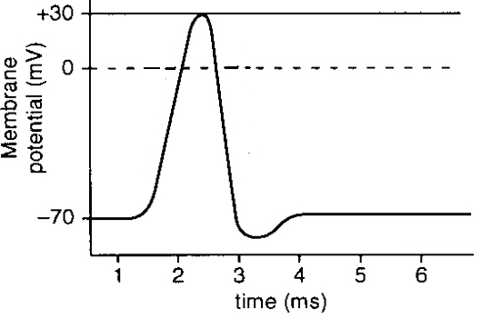
5. Explain the chart to the right:

6. Explain how an action potential is passed down the length of an axon.

7. Explain how myelin sheaths speed up transmission of an action potential. A sketch would be nice

8. Draw a picture of a synapse

9. Using your drawing, explain a signal is passed from one neuron to the next via the synapse

10. Describe some examples of responses to neural signals

