Neurons Practice Problems
1. Almost all sensory receptors (with the exception of vision which works in a somewhat backwards manor) involve opening of sodium channels or leakage of sodium into the neuron. Which of the following best describes the effect?
A. Depolarization of the neuron
B. Maintenance of a strongly negative resting voltage
C. Inhibition of neural firing
D. A large decrease in the resting voltage
2. The transmission of a neural signal across the length of the axon can best be thought of as a flow of
A. Negative charge B. Neurotransmitters C. Calcium ions D. Positive charge
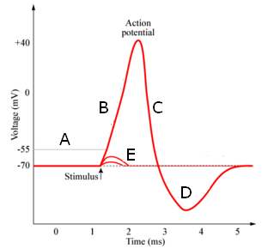
3. Briefly describe what is occurring at each letter on the graph which shows the voltage across a neuron during an action potential
A
B
C
D
E

4. At the synaptic terminal neurotransmitters are released which can pass on the signal to the next neuron. Which of the following best describes the effects of these neurotransmitters?
A. They stimulate the release of calcium from the post-synaptic cell which initiates a new action potential
B. They stimulate opening or closing of ion channels which can stimulate or inhibit a new action potential from forming
C. They stimulate the release of a chemical signal molecule from the post-synaptic cell which may stimulate or inhibit new action potentials from forming
D. They stimulate an intake of calcium by the post-synaptic neuron which immediately leads to the release of a second neurotransmitter
5. Describe what causes the release of neurotransmitter from a synaptic terminal

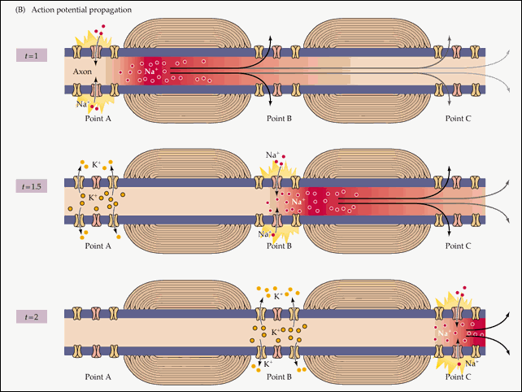
6. The diagram to the left best shows
A. How myelin speeds up transmission of an action potential
B. How neurons receive signals via neurotransmitters
C. How a neuron can be inhibited from firing an action potential
D. How the resting membrane voltage is created across the neuron

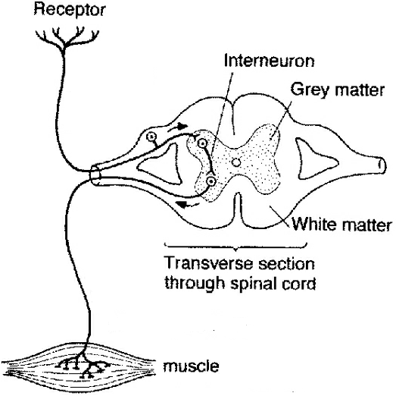
7. Based on the diagram to the right, if the neuron identified by the arrow was dysfunction, it would cause
A. An inability of the muscle to respond to sensory signals
B. An inability of the sensory neuron to detect stimuli
C. Increased action potentials in the motor neuron leading to the muscle
D. An inability to integrate sensory information
8. The sensory neuron will lead to a response in the interneuron by
A. passing along positively charged ions
B. releasing a neurotransmitter which can bind to receptors of the interneuron
C. passing the action potential across the synapse
D. releasing calcium ions from the synaptic terminal

9. Describe how each of the following play a role in the nervous system
A. Active transport

B. Facilitated diffusion

C. Exocytosis

10. An inhibitory signal from one neuron to the next would be accomplished by releasing a neurotransmitter that
A. binds to and opens calcium ion channels B. triggers opening of sodium channels
C. triggers opening of potassium channels D. shuts off the sodium-potassium pump

