The Difference Between:
Eukaryotes, Prokaryotes, and Viruses
What is Cell Theory?

What is Germ Theory?

 | Prokaryotes | Eukaryotes | Viruses
Cells Contain  (For Virus Fill In the Parts) | Pro=  Karyo= | Eu=  Karyo= | 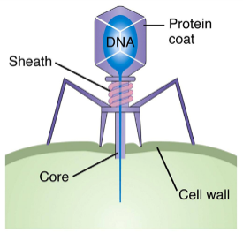
Subdivisions | 1.  2. | 1.  2.  3.  4.
Alive or dead?
Illnesses Caused  (Just a few examples of the many…) | 1.  2.  3.  4. | 1.  2. | 1.  2.  3.  4.
General Size!?
(Draw from slide After Viruses)

