Chromosomes Practice Quiz

1. Two strands of DNA are sister chromatids. This means
A. They have the exact same sequence
B. They contain different versions of the same genes
C. They are both recessive
D. They are homologous to each other
2. Half of the sons in a very large family are color blind while none of the daughters are. Which scenario is most supported by the data?
A. Both parents are color blind
B. The mom is color blind only
C. The dad is color blind only
D. Neither parent is color-blind
3. If two genes are linked we would expect
A. Them to often be inherited together
B. Them to both be recessive
C. Them to be inherited independently
D. Them to be more common in females than males
4. A and B are unlinked. If an Aabb individual mates with an aaBb individual, we would expect___ to show the dominant trait in both genes
A. 0% B. About 25%
C. About 50% D. About 75%
5. At the molecular level, explain the inheritance pattern of incomplete dominance

6. A man inherited color blindness. He cannot have inherited this trait from
A. His mother B. His mother’s mother
C. His mother’s father D. His father
7. The genes for wing shape and body color are located very close together on a fruit fly’s autosomal chromosome. Gray color and normal wings are dominant to black color and vestigial wings. If a male that is heterozygous in both traits mates with a black vestigial winged female and the dominant alleles are on different homologous chromosomes for the male, what would we expect the offspring to be?
A. About evenly split (25%) between gray-normal wings, gray-vestigial wings, black-normal wings and black-vestigial wings
B. About half gray-normal wings, half black-vestigial wings
C. About 75% gray-normal wings, 25% black-vestigial wings
D. About half gray-vestigial wings, half black-normal wings
8. Based on the recombinant frequencies below, identify the most plausible chromosome map.
AB-10 AC-5 AD-35 BC-15 BD-25 CD-40
A. ACDB B. CDAB
C. DACB D. CABD E. ABDC
9. A trait like height, which varies along a continuum is an example of
A. Incomplete dominance B. Co-dominance
C. Polygenic inheritance D. Epistasis
10. A data set does not match any predicted pattern of complete, incomplete, co-dominance or sex linkage. Identify as many possible explanations as possible

White eyed black bodied fruit fly males are mated with red eyed gray bodied fruit fly females and the resulting offspring are all red-eyed and grey. The F1 males are then mated with white-eyed black bodied females. The result of this mating is 4 unique morphs. The number of offspring with each phenotype is displayed below
Morph | White-eyed black | White-eyed gray | Red-eyed black | Red-eyed gray
# of F2 showing | 193 | 19 | 14 | 187
11. Which traits must have been dominant? Explain how you know

12-14 (3 points) Explain the pattern of inheritance shown in the data above. This should include a cross explaining the data and an explanation of any variance from what your cross would suggest.

15. Use a Chi Squared test to test your hypothesized answer
x | x | x | x
The degrees of freedom are ______.
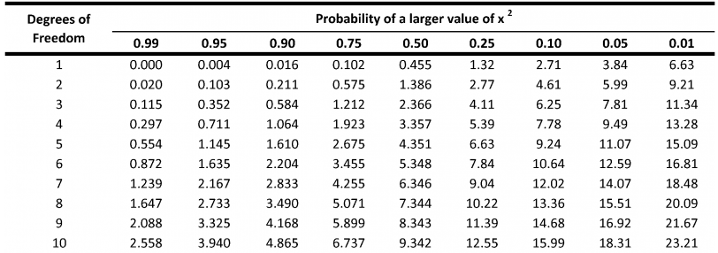
P value range___________________
Does this test support or refute your hypothesis?

More Practice (Challenge Questions)
16. Eye color is predominately determined by two genes. The first gene has two alleles, a dominant brown allele and a recessive allele, which allows the second allele to be expressed. Individuals with the brown allele have brown eyes regardless of the second gene. For the second gene, the green allele is dominant to the blue allele. (*this explains the majority of eye inheritance, but there are many exceptions and it doesn’t explain alternate eye colors like hazel) Your dad has brown eyes, your mom has blue eyes and you have green eyes. You fall in love with your new mate based on his/her beautiful brown eyes. Your mate’s mom had blue eyes as did his/her sister. His/her brother had green eyes.
Figure out everyone’s genotype and map it on a family tree.

17. Predict the odds that your first child will have each of the possible eye colors

18. A man and a woman are members of a weird cult and end up having 40 babies, 20 boys and 20 girls. Eight of the boys suffer from both color blindness and hemophilia. One boy has color blindness only and one boy has hemophilia only. None of the girls are afflicted by either disorder nor are the parents. Draw the cross to explain this family below and explain what is going on.

