Homeostasis Practice Quiz
1. Which of the following is the best example of an organism maintaining dynamic homeostasis?
A. Squirrels store extra food for the winter months when food might be scarce
B. When carbon dioxide levels in the blood are high the brain triggers the diaphragm to breath more
C. Plants soak up nitrogen from the soil that has been fixed by nitrifying bacteria
D. Plants placed in hypertonic solutions lose water and begin to wilt
2. When blood calcium is low, Parathyroid Hormone is released. Predict the consequences that parathyroid hormone will have on the body

3. Which of the following is an example of a positive feedback mechanism?
A. When there are high levels of ATP in cells the enzymes of glycolysis are shut off
B. When there are high levels of lactose present in the body the genes that code for lactase (an enzyme that digests lactose) are activated
C. During the menstrual cycle rising estrogen levels trigger ovulation, which in turn increases estrogen levels further
D. When the concentration of glucose in the blood is low, glucagon is released to stimulate breakdown of glycogen molecules
4. The thyroid gland normally releases hormones that stimulate metabolic activity in the cell, increasing the rates of reactions. A person with Grave’s disease suffers a disorder of the thyroid causing individuals to be jumpy, have trouble sleeping, have difficulty putting on weight and other symptoms. This disease most likely occurs as a result of
A. inactivity of the thyroid gland
B. the normal consequences of a negative feedback loop
C. a failure of a negative feedback loop to stop release of thyroid hormones
D. a failure of a positive feedback loop to increase release of thyroid hormones
5. When feline body temperatures rise above a set point, we would expect to see
A. the cat to become more active
B. the cat to engage in activities that help release heat to the environment
C. the cat to be excessively hungry and look for food
D. the cat to curl into a ball
6. Describe a negative feedback loop, giving an example

The diagram below represents a series of experiments designed to examine phototropism (growth towards light) in plants and will be used for questions 6-7.
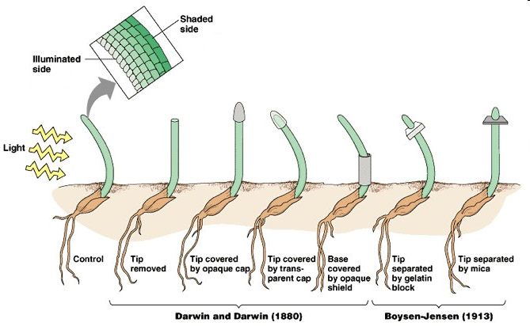
7. Based on the experiment, which of the following appears necessary for phototropism to occur?
A. The entire stem must be exposed to light on one side
B. Only the tip of the plant must be exposed to light one side
C. Light does not have an effect on the direction of plant growth
D. Any part of the plant must be exposed to sunlight for phototropism to occur
8. Which of the following conclusions is supported by the study?
A. A signal that can pass through mica (a silicate material) helps spur growth of cells
B. A signal that can pass through gelatin is passed up the stem to the tip of plants
C. A signal that can pass through gelatin is passed from the tip of the plant down through the stem
D. A signal that can pass through mica is passed up the stem to the tip of plants
9. What is the purpose of running a trial with a top covered by a transparent cap?

10. Fish and amphibians excrete nitrogenous waste (a byproduct of protein metabolism) as ammonia, which is toxic at high concentrations, while birds, reptiles, and mammals first convert the ammonia into another form. Which of the following best explains the existence of this conversion process?
A. Converting ammonia into other forms is a more energy-efficient process than excreting ammonia
B. Terrestrial animals with adaptations to convert ammonia into other forms required less water and were more likely to survive on land
C. Converting ammonia to other forms reduces the amount of proteins required in the diet for terrestrial mammals
D. Converting ammonia into other forms allows animals to excrete more dilute nitrogenous waste products to avoid poisoning their environment

