DNA Practice Quiz
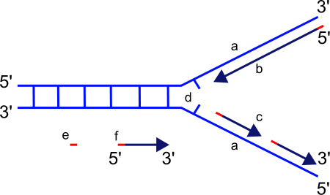
1. When DNA is heated mildly the strands can be stimulated to separate, which is used in a mechanism called PCR to rapidly produce copies of DNA. The heating separates the strands from each other but does not degrade each individual strand because
A. phosphates and sugars are more resistant to heat than nitrogenous bases
B. hydrogen bonds are not affected by heat
C. phosphodiester bonds are much weaker than hydrogen bonds
D. it takes more energy to break the covalent bonds than hydrogen bonds
2. Describe what is occurring at letter C on the diagram to the left

3. Which of the following properties of DNA best explains the occurrence you described in #2?
A. DNA is found in a double-stranded double-helix which twists in a right-handed fashion
B. DNA strands are anti-parallel and run in opposite directions in terms of the 3’ and 5’ ends
C. In DNA bases pair with each other in a predictable fashion in which a purine always bonds with a pyrmidine
D. The DNA molecule is wrapped around histone proteins which control access to the DNA
4. A sample of DNA is first synthesized in an environment where all of the nitrogen atoms are heavy atoms of nitrogen (¹⁵N), causing all of the original DNA strands to be heavy. The DNA is then replicated in a new environment. Eventually the DNA is placed in a machine that separates the molecules by weight. Which of the following situations would produce the results shown below?
A. Allowing the DNA to replicate once in an environment where only heavy nitrogen is available
B. Allowing the DNA to replicate once in an environment where light nitrogen (¹⁴N) is available
C. Allowing the DNA to replicate two or more times in an environment where light nitrogen is available
D. Allowing the DNA to replicate two or more times in an environment where only heavy nitrogen is available
5. Which of the following best explains why the base pair formed between cytosine and guanine holds DNA strands together more strongly than the base pair between adenine and thymine
A. C and G bases are held together by phosphodiester bonds while A and T bases are held together by hydrogen bonds
B. C and G bases are held together by hydrogen bonds while A and T bases are held together by phosphodiester bonds
C. C and G bases are held together by two hydrogen bonds while A and T bases are held together by three hydrogen bonds
D. C and G bases are held together by tree hydrogen bonds while A and T bases are held together by two hydrogen bonds

6. The Avery, Macleod and McCarty experiment sought to explain the findings of Frederick Griffith, who in 1928 showed that when heat-killed virulent bacteria were mixed with live non-virulent bacteria the non-virulent strains were “transformed” into virulent bacteria and were capable of killing a mouse, as shown below.
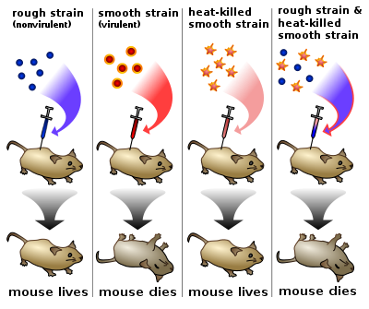
Explain their findings

7. Which of the following diagrams most accurately represents DNA synthesis?
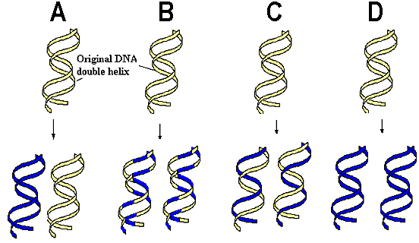
8. Explain why radioactive Sulfur and radioactive Phosphorous were important tools in the Hershey-Chase experiment.

9. The ability for genes to be expressed depends heavily on
A. The number of hydrogen bonds formed between the two strands of the DNA
B. How tightly coiled the gene is wrapped around proteins
C. How tightly wound the double helix in the gene is
D. How long the DNA sequence in the gene is
10. A strand of DNA is 5’ TACGACTG 3’. The other strand of DNA must be
A. 5’ TACGACTG 3’ B. 3’ TACGACTG 5’ C. 3’ ATGCTGAC 5’ D. 3’ GTCAGCAT 5’ E. 5’ ATGCTGAC 3’
Explain:

