Name:__________________________________________
Date:________________________
What Did T-Rex Taste Like?
http://www.ucmp.berkeley.edu/education/explorations/tours/Trex/index.html
Mods:______________________
Folder 1:
- What shows how living things are related to one another? ____________________________

- Name and describe the three groups shown on the branching tree (you will have to click on each group for information)?

- Define the word “lineage”.

- All life can be traced back to a ____________________ _____________________.

- Why does everyone in a family not look exactly alike?

- What are the 2 big ideas to keep in mind from folder 1?
Folder 2
- Put the names on the tips of the branches below based on the tree in folder 2.
- Then draw a circle on the most recent common ancestor of the parrot and the caiman.
- Then put a star on the most recent common ancestor of the tuna and the parrot.

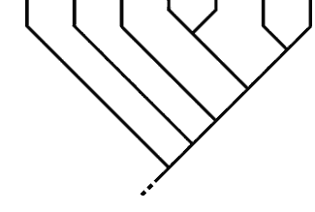

- What is the basis for determining how closely related organisms are? _____________________________

Folder 3:
- _______________________________ illustrate evolutionary relationships based upon shared inherited features.

- What are lineages used for?

- Which is more closely related to caimans- hares or parrots? Explain why?

- Cladograms represent hypotheses about evolutionary relationships. These relationships are based on ______________________ ______________________ that have been inherited from a common ancestor.

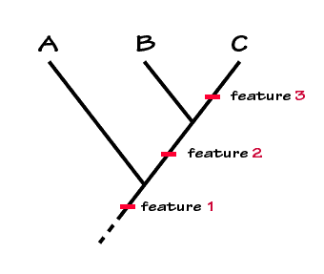
- In the cladogram below what does feature 1 provide evidence for?

- Label characters A-F based on the tree in folder 3. Find the character by clicking each letter.
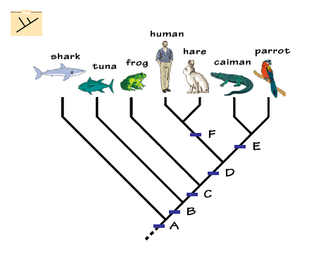
- What feature do all of the organisms share?

- Which organisms are tetrapods?

- How do we know the skull openings were present in the common ancestors if we can’t see them today?
Folder 4:

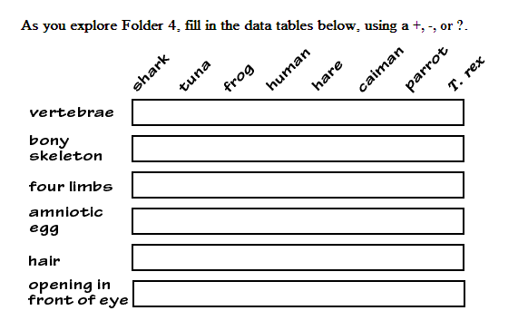

- Fill in the chart below as you start to look at the cladogram of caiman, parrot, and T. rex.
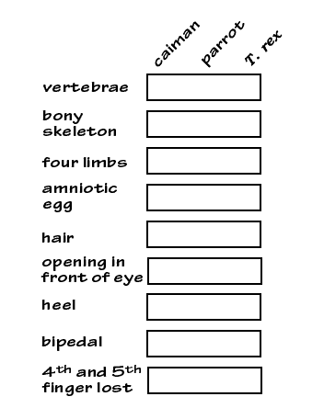
- Based on the table which organism is T-rex more closely related too? Caiman or Parrot?
- Based on your data…what did t-rex probably taste the most like?
  - Chicken b. Roast Beef c. Tuna

- Because T-rex was bipedal and had a reduced number of fingers, we can infer:
  - That T.rex was more closely related to birds than to crocodiles
  - That T.rex and birds inherited these features from a common ancestor
  - That T.rex probably shares more features with birds than with other vertebrates
  - All of the above
  - None of the above
Folder 5
Complete the special assignment. Read all directions given. Cladogram and additional data are provided.
